Basic Pointers
Purposes:
Screening
Demographics
Eliciting the Story, Opening the
Unconscious & Memory Bank
Warm Up
Present Tense
Questions, prompts
Avoid theoretical, academic
language
“Think of a time….”
“Tell me about a time….”
Qualities of effective qualitative interviews
Rich description, Voice
Authenticity, Resonance
Interviewer stance
Bracket, practice, clarify role
Exepect emotions, journal

Ver, J.M. Transpersonal Creativity: the alchemy of indgenous art and craft.

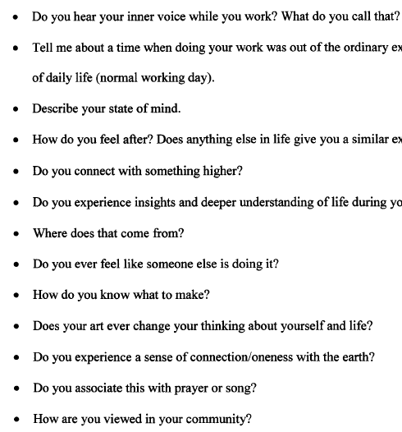
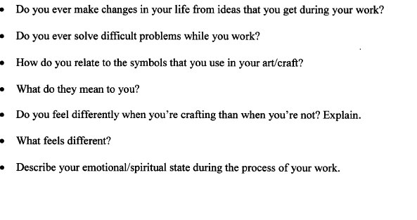

Anding, J. M. Opting in: the experiences, pathways, and meaning of successful, professional, generational X women making intentional career transitions
Demographic Questions
• Date of Birth
• Birthplace
• Ethnicity
• Education
• First-Generation College Student
• Relationship Status
Children
• Siblings
• Primary Breadwinner Status

First Structured Interview

Describe your experience of making an intentional decision to exit your
upwardly mobile career path.
• Describe what a typical day was like for you during this time. Walk me
through your day. Does anything stand out in your mind about what was
happening for you internally during this time?
• Describe ways in which your cultural worldviews influenced you during this
time.
• Describe ways in which your societal worldviews helped or hindered you
during this time.
• Is there anything else you'd like to share with me about this particular time in
your life?

Second Structured Interview

As you reflect back on that time, how do you currently make meaning of the
experience?
• Describe how the experience of leaving an upwardly mobile career path has
impacted other aspects of your life.
• Describe in what ways, if any, you feel you were transformed by this experience.
• In what ways have your cultural worldviews been impacted by your transition?
• In what ways have your societal worldviews been impacted by your transition?
How do you live your life different today as a result of your experience making
this career transition?
• Are there any final thoughts that you'd like to share about your experience?

Lanier, M. H. Experiencing isolation: professional African American 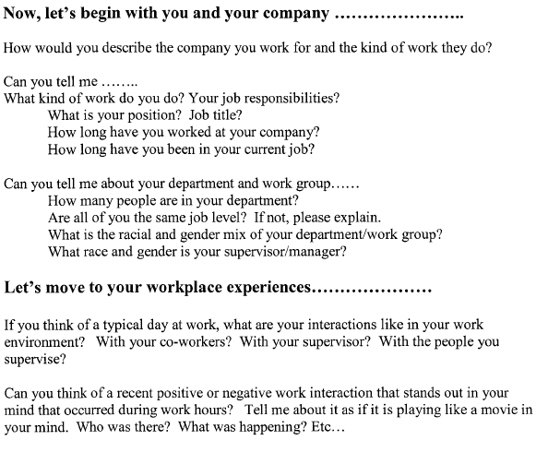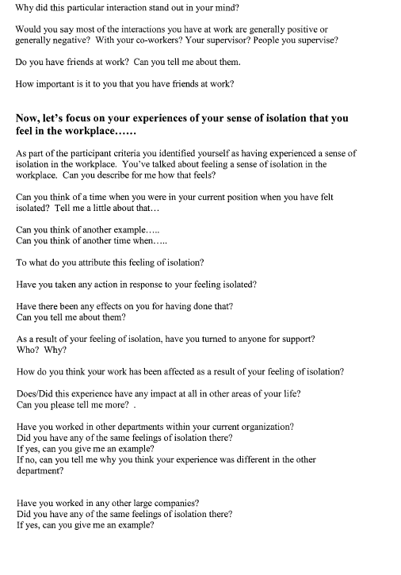
Jensen, L. M. Working and fathering: cultural and experiential implications for personal growth and learning

